**Customer Success Platform**

**(Amandeep Rewani)**

**Introduction**

This project's objective is to develop a Customer Success Platform that automates the process   
of notifying stakeholders about any updates or changes within our system. The application aims   
to enhance communication and transparency by ensuring that all stakeholders are promptly   
informed whenever there is a relevant update.

**Features of the Project**

1. **Project Description:** A brief overview of the project, including its purpose, goals, and objectives.
2. **Scope:** Defines the project's boundaries, including what is included and excluded from the project scope.
3. **Project Stack (Tech):** Describes the technologies and tools that will be used in the project, including backend, frontend, mobile app, database, and infrastructure.
4. **Escalation Matrix:** Outlines the hierarchy and process for escalating issues or concerns within the project team.
5. **Stakeholders:** Identifies the individuals or groups who have an interest or stake in the project, such as the project manager, client, and account manager.
6. **Risk Profiling:** Assesses potential risks to the project and outlines steps for managing and mitigating these risks.
7. **Phases/Milestones:** Breaks down the project into manageable phases or milestones with specific start and completion dates.
8. **Sprint wise detail:** Provides details of each sprint, including start and end dates, status, and comments.
9. **Approved Team:** Lists the members of the project team, their roles, and their availability.
10. **Resources:** Identifies the resources required for the project, including human resources, equipment, and materials.
11. **Client Feedback:** Documents feedback received from the client, including complaints, appreciation, and action taken.
12. **MoMs of client meetings:** Records minutes of meetings with the client, including dates, duration, and key discussion points

**Technology Used:**

**Frontend: ReactJS**

ReactJS is a JavaScript library for building user interfaces, developed and maintained by Facebook. It is widely used for creating interactive and dynamic web applications with a component-based architecture. In the Customer Success Platform, ReactJS is utilized to develop the frontend user interface, enabling seamless navigation, efficient data management, and a responsive user experience. Its component-based approach allows for modular development and easy maintenance of code, facilitating the creation of scalable and customizable frontend components.

**Backend: Node.js**

Node.js is a server-side JavaScript runtime environment built on Chrome's V8 JavaScript engine. It allows developers to run JavaScript code on the server, enabling the development of scalable and high-performance web applications. In the Customer Success Platform, Node.js serves as the backend technology, handling server-side logic, processing requests from the frontend, interacting with the database, and managing application logic. Its event-driven, non-blocking I/O model ensures optimal performance and enables the platform to handle concurrent requests efficiently, making it suitable for building real-time and data-intensive applications.

**Database: MongoDB**

MongoDB is a popular NoSQL database management system that uses a document-oriented data model. It provides flexibility, scalability, and high performance for storing and retrieving data, making it well-suited for modern web applications. In the Customer Success Platform, MongoDB serves as the backend database, storing various types of data such as user information, customer profiles, transactional data, and application settings. Its schema-less design allows for dynamic and agile development, accommodating changes in data structure without downtime or migration issues. MongoDB's rich query language, indexing capabilities, and horizontal scalability support the platform's requirements for data storage, retrieval, and analysis.

**Integration of Technologies**

The Customer Success Platform leverages the integration of ReactJS for the frontend, Node.js for the backend, and MongoDB for the database to deliver a robust, scalable, and responsive application. This technology stack enables efficient development, seamless communication between frontend and backend components, and effective data management, empowering businesses to deliver exceptional customer experiences and drive success in today's competitive landscape.

**Functionality of the project**

1. **CRUD for each section of Project Charter:**   
   a. 15 Section CRUD: There are total 15 section of Customer Success platform   
   (Project Budget, Version History, Audit History,Project Description, Scope, Project Tech Stack, Escalation Matrix, Stakeholders, Risk Profiling, Phases/Milestones, Sprint Wise Details, Detailed timeline reference, Approved Team, Resources,Client Feedback, MoM of client meetings). Develop Create/Read/Update/Delete functionality for each of the 15 sections.
2. **Registration and Login with Microsoft using Auth0:**

Users can register for an account on the platform by providing basic registration information or by logging in using their Microsoft accounts via Auth0.

1. **Role Based Management:**

**Admin Role**

i. Create static credentials for Admin Role. Mention the credentials in the

readme file.

ii. Admin should be able to have full access to create/update/read/delete all

projects in customer success platform.

iii. Admin should be able to have full create/update/read/delete access of all

sections of each project in customer success platform.

iv. Admin should be able to Create/Read/Update/Delete users (all

stakeholders).

**b. Auditor Role**

i. Can register for an account on the platform using their Microsoft

credentials through the Auth0 authentication service.

ii. Should have access to create/select existing project

iii. Should have access to assign a project manager to the project so that

Project manager while login in should be able to go to the project for

which he/she needs to update customer success platform.

iv. Should have the ability to add stakeholders of the project that should

automatically display in Stakeholders table in customer success platform

for current project

v. Should have access to view the customer success platform for all projects.

vi. Should have access to add comments in the ‘Audit History’ table.

**c. Project Manager Role**

i. Can register for an account on the platform using their Microsoft

credentials through the Auth0 authentication service.

ii. Project Manager should be able to access add/edit/delete existing

content of the customer success platform for assigned project/s

iii. Project Manager should be able to save and submit the updated

customer success platform for his/her assigned project/s

**d. All other stakeholders’ Role**

i. All stakeholders should be able to view the customer success platform for

assigned projects to him/her.

1. **Email Notification System:**

Send email notification to all stakeholders when Audit History table is updated in customer success platform.

1. **Export as a Document:**

Implementing the functionality to export project details as a document in a predefined format. Additionally, working on the First 10 CRUD operations (Project Budget, Version History, Project Description, Scope, Project Stack (Tech), Escalation Matrix, Stakeholders, Risk Profiling, Phases/Milestones, Sprint wise detail, Detailed timeline reference) from the provided template to understand the type of operations to be exported as PDF.

**Third Party Integration**:

**Auth0: Overview**

Auth0 is a flexible, easy-to-implement authentication and authorization platform that allows developers to add robust identity management to their applications. It offers features such as single sign-on (SSO), social login, multi-factor authentication (MFA), and role-based access control (RBAC), helping developers secure their applications and protect user identities.

**Integration in the Customer Success Platform:**

In the Customer Success Platform, Auth0 is utilized to handle user authentication and authorization requirements. By integrating Auth0, the platform ensures that only authenticated users can access its features, and each user's access privileges are carefully managed based on their assigned roles and permissions.

**Auth0 Management API:**

The Auth0 Management API is utilized in the Customer Success Platform to programmatically manage users, roles, and permissions. This API allows the platform to automate user management tasks, such as creating new users, updating user profiles, and assigning roles dynamically based on user attributes or actions.

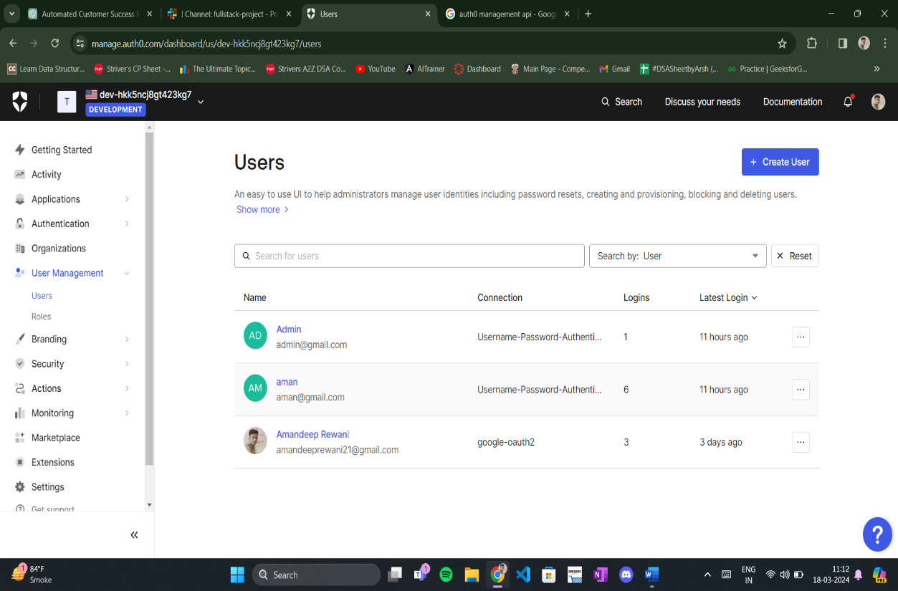

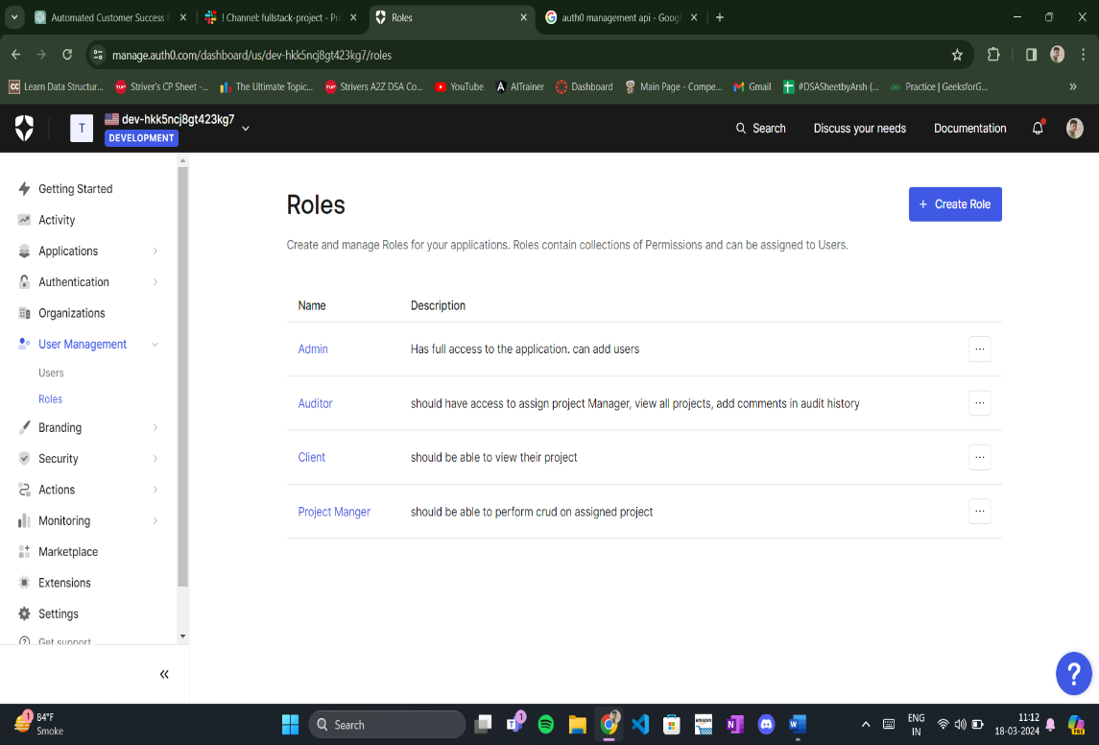

Login Credentials for Admin has been Mentioned in the README file.

Once admin creates an user then the user has to rember the credentials to login with it in the customer success platform.